Module 4 - Test driven development and Logging framework
Exercise 1: Setting Up Junit
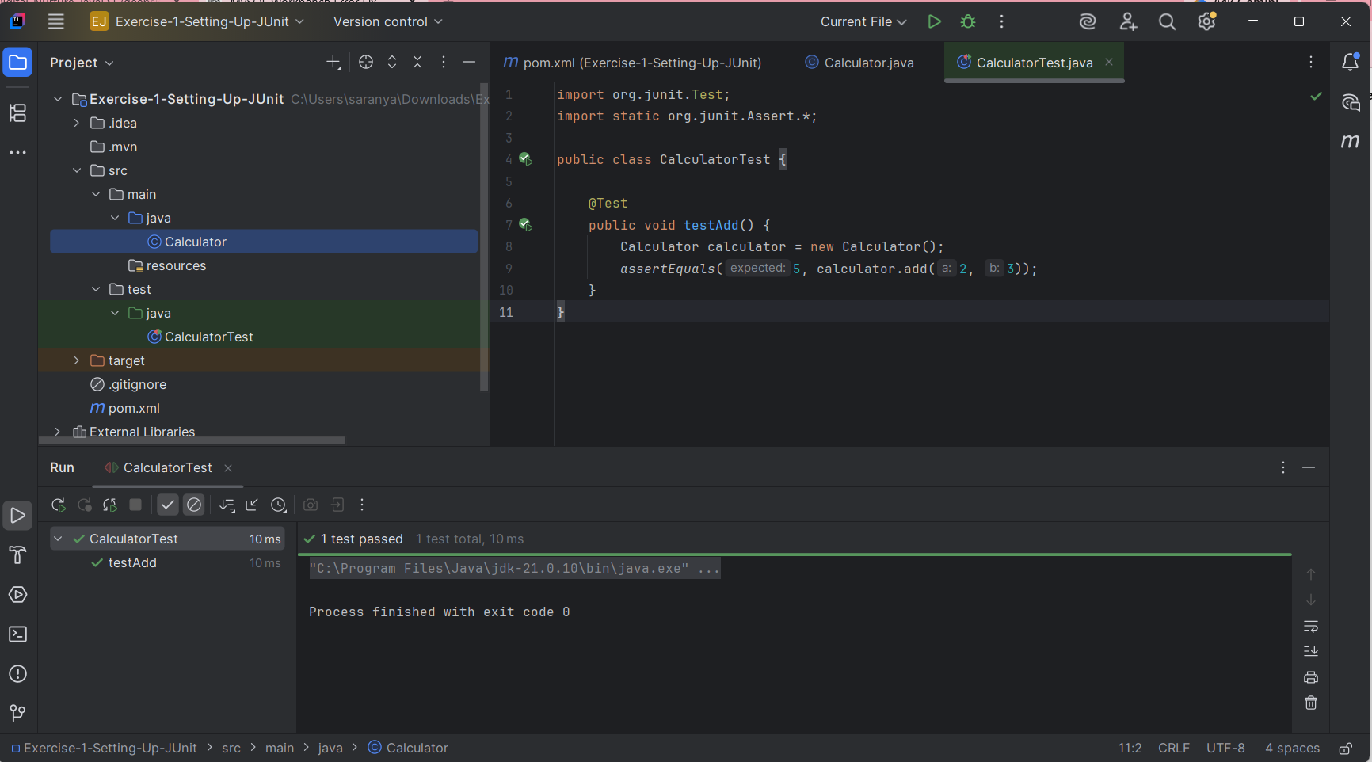
Exercise 3: Assertions in JUnit
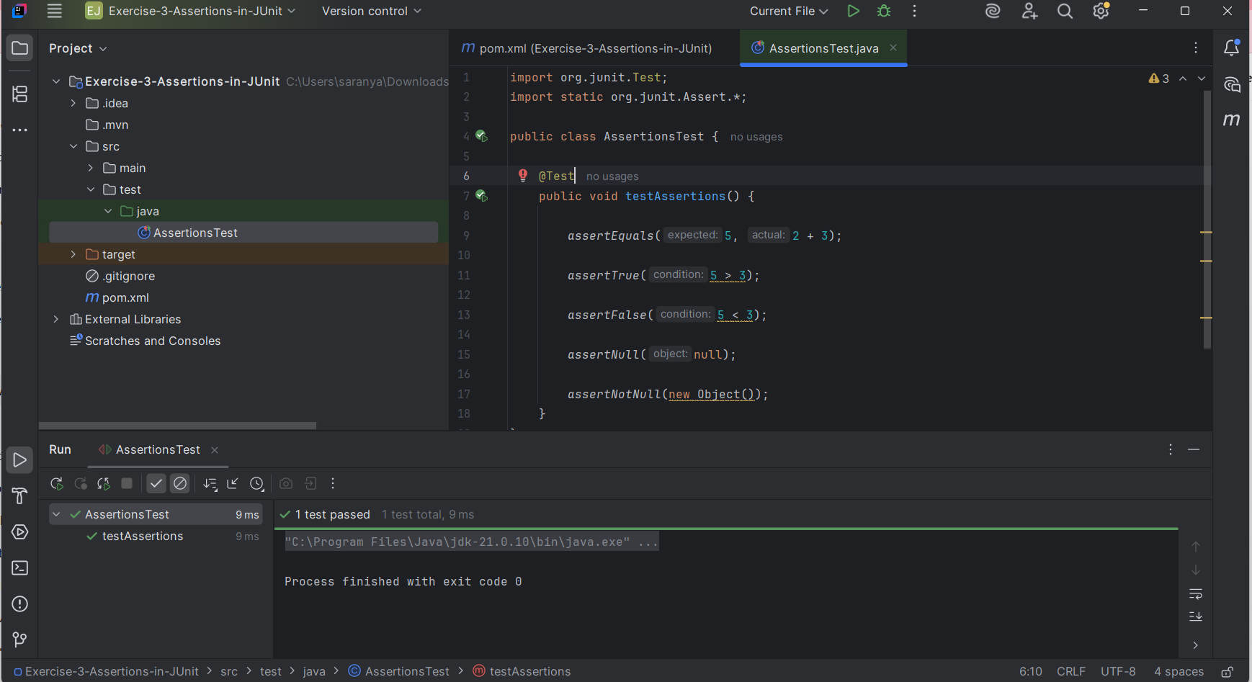
Exercise 4: Arrange-Act-Assert (AAA) Pattern, Test Fixtures, Setup and Teardown Methods in Junit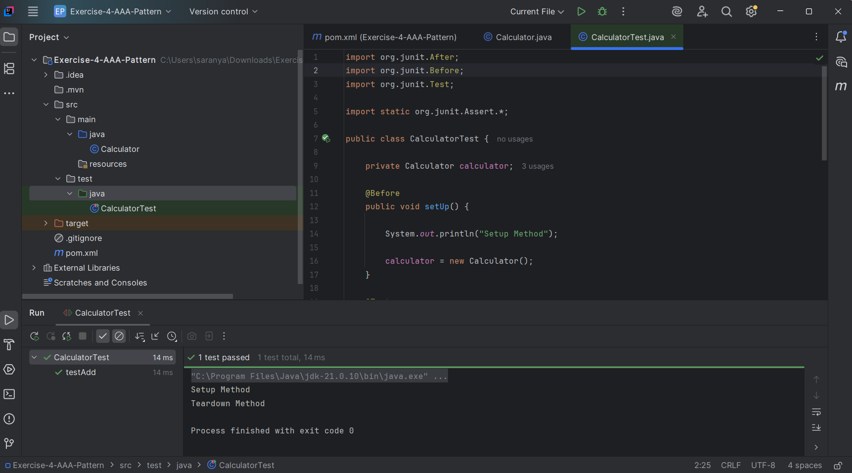
Exercise 1: Mocking and Stubbing
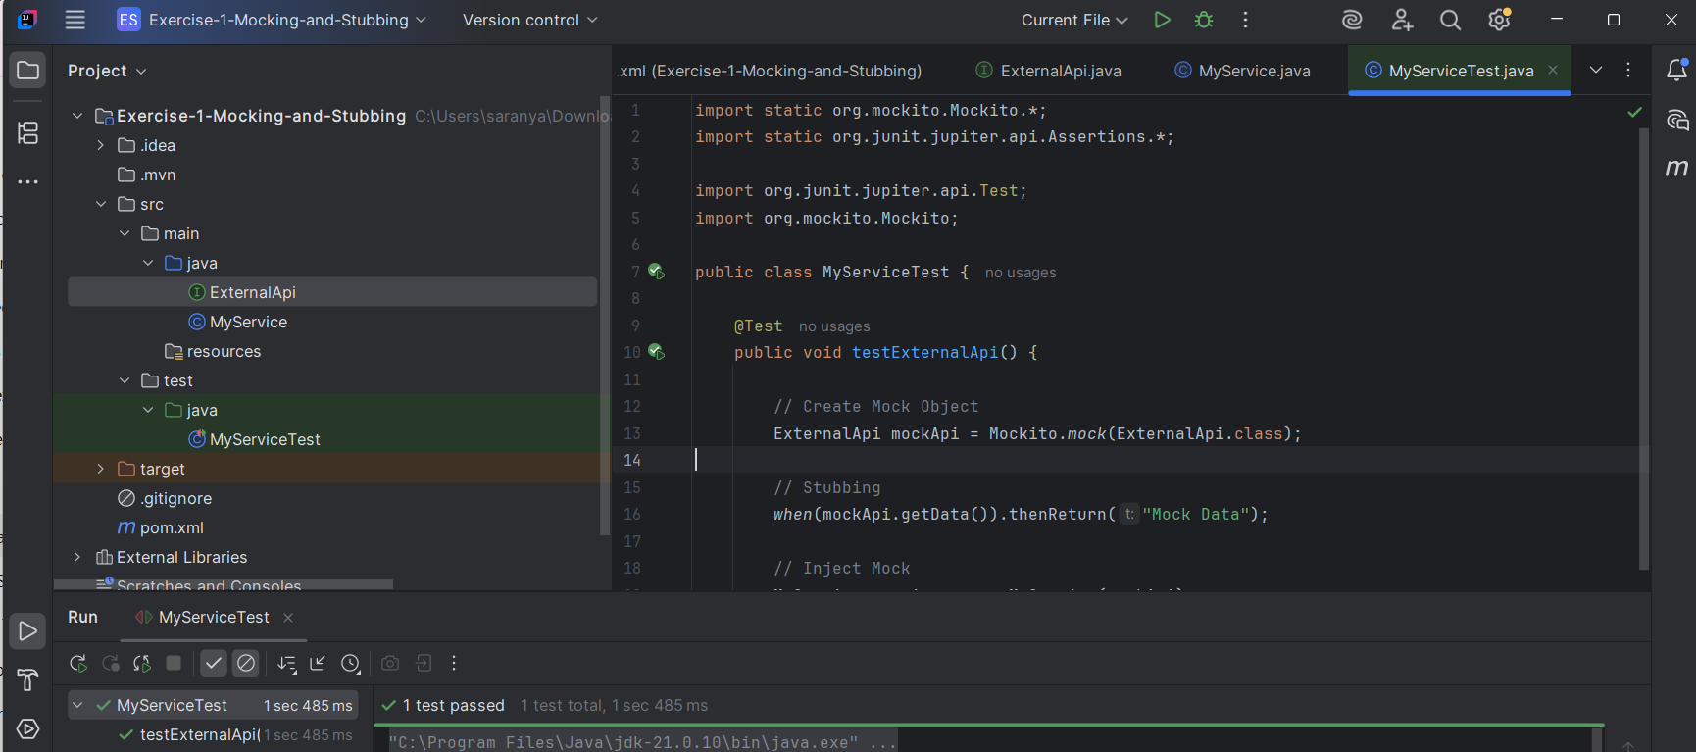
Exercise 2: Verifying Interactions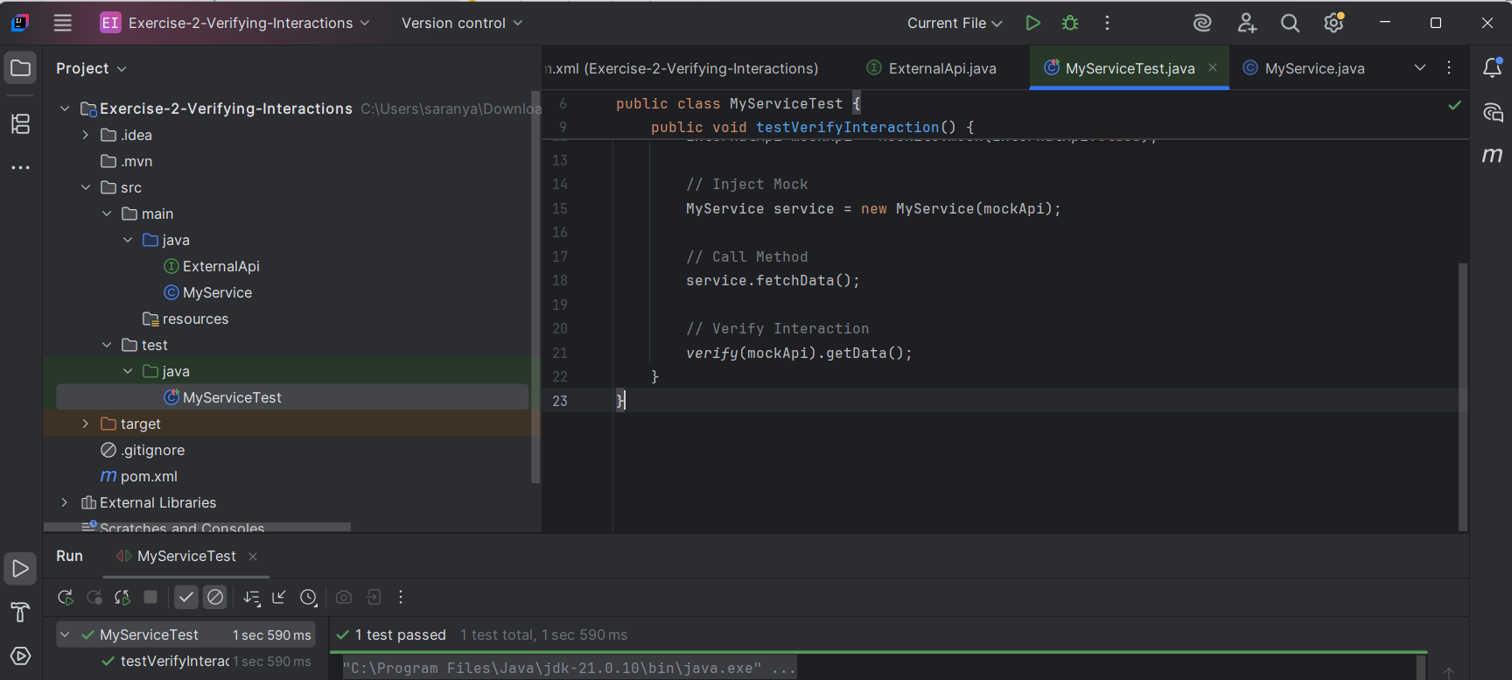
Exercise 1: Logging Error Messages and Warning Levels
